**ASSIGNEMENT NO: 01 (Roll Number: From 01-15)**

Square Matrix, Off-Diagonal , Lower Triangular Matrix, Symmetric Matrix, Orthogonal Matrix, Unitary Matrix, Graph, node, link, rank of graph, oriented graph, Indegree and Outdegree.

**ASSIGNEMENT NO: 01 (Roll Number: From 16-30)**

Tree, Twigs, Chords, Cotree, Cut Vertex and Cut-sets, Incidence Matrix, Tie set Matrix, Cut-set Matrix, Element node-incidence matrix, Bus Incidence Matrix, Branch-path incidence matrix,

**ASSIGNEMENT NO: 01 (Roll Number: From 30-onwards)**

Primitive Network, Bus Impedance and Bus Admittance Matrix, Difference between symmetrical and unsymmetrical systems, Phase Sequence, Per-unit systems, Faults and Types of Faults, Define Slack Bus, Load Bus and Generator Bus, Write Power Flow Equations.

POWER FLOW EQUATION

Q: Find the element-node incidence matrix of the graph as shown in Figure given below

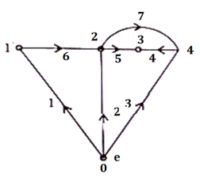

Q: **Find the Bus Incidence matrix of the graph as shown in Figure given below**

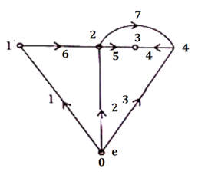

Q: **Find the Branch-Path Incidence Matrix of the given directed graph as shown in Figure below:**

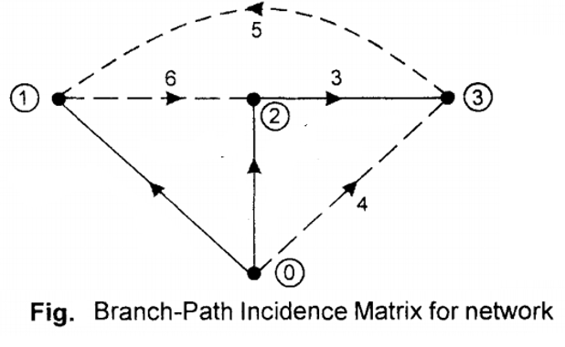

Q: **Draw the cuts on the below oriented graph?**

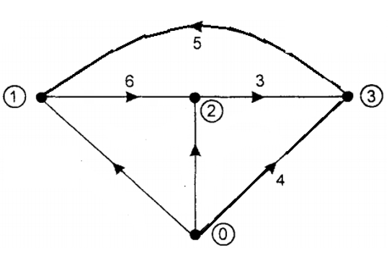

Q: Calculate the Basic Tie Set Matrix

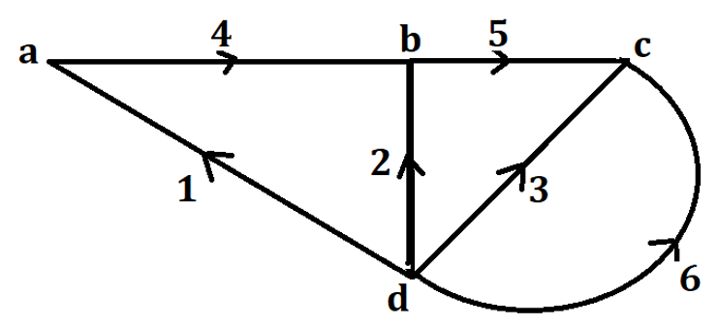

Q: For the Power System shown in Figure below, draw the graph, tree and its co-tree?

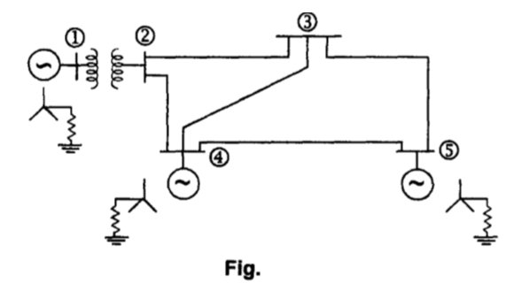

Q: For the circuit shown below, draw the oriented graph and write:

1. Incidence Matrix
2. Tie Set Matrix

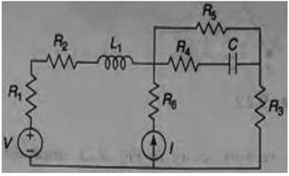

Q: Find the bus admittance matrix, Ybus (see Lecture No: 4, Slide 15)

Q: Calculate the Bus Admittance matrix from the give power system diagram having impedances values are present in the Figure (See Lecture No 4 Slide 18)

Q: Verification by Inspection Method (See Lecture 4, Slide 22)

Q: Apply the Singular Transformation Method on given reactance diagram as shown in Figure, to calculate the YBUS matrix (See Lecture No 4 Slide 19)

Q: Form the YBUS matrix using Kron Method (see Figure in Lecture No 5)

Q: Find the bus impedance matrix for system below having three buses connected with ground (See Lecture 5 Slide 13).

Q: Find the bus impedance matrix of four bus connected system as shown below (See Lecture No 5 Slide 17).

Q: Determine the Phase Sequence of different set voltage?

Q: Calculate the currents in Y-Y system

Q: Find the faults current in the following systems (See Lecture 9)

Q: Solve the systems of equations using Cholesky Method

Q: Solve the systesm of equations using Crouts Method

Q: Solve the problem of power flow equation using Gauss Seidal Method

Q: Determine the unknown states of power systems using Newton Raphson Method.